**EDA Report for a Sales Dataset**

**Introduction**

* **Objective:** Understand sales trends, customer behavior, and profitability.
* **Dataset:** Contains sales transactions, customer details, and product information.

**Dataset Description:**

This dataset contains **51290 records** and **39 columns**, covering various aspects of **sales transactions**. It includes details about **customer orders**, including **sales, discounts, profits, shipping costs, and product categories**. Additional features such as **season, weekday, economic indicators, and promotions** are also present.

**Purpose:**

The dataset is designed for **Exploratory Data Analysis (EDA)** to uncover insights into **sales performance, profitability, customer behavior, and the impact of discounts and shipping costs on business revenue**. It can help businesses **optimize pricing, improve marketing strategies, and enhance operational efficiency**.

**Key Insights:**

1. **Sales vs. Profit** (Scatter Plot)
   * There is a **positive correlation** between sales and profit.
   * Higher sales generally lead to higher profits, but some **high-sales transactions have low or negative profits**, indicating possible discounting issues or cost inefficiencies.
2. **Total Sales by Category** (Bar Chart)
   * Some product categories contribute significantly more to total sales than others.
   * The **top-performing categories** should be prioritized in marketing and inventory management.
3. **Discount vs. Profit** (Scatter Plot)
   * A **negative correlation** exists between discount percentage and profit.
   * Higher discounts tend to reduce profitability, suggesting that discounting strategies should be carefully optimized.
4. **Sales Distribution by Season** (Box Plot)
   * Sales tend to fluctuate across different seasons, with peaks in specific quarters.
   * This insight can help businesses plan **seasonal promotions** and **stock adjustments**.
5. **Total Sales by Ship Mode** (Bar Chart)
   * Some shipping methods generate higher sales than others.
   * Businesses may want to **incentivize cost-effective shipping options** that maintain customer satisfaction.
6. **Quantity vs. Sales** (Scatter Plot)
   * There is a pattern indicating that **bulk purchases lead to higher total sales**.
   * This can guide strategies for bulk pricing or wholesale promotions.
7. **Region-wise Profit** (Bar Chart)
   * Some regions are more profitable than others.
   * Companies can adjust their **regional sales strategies** and **marketing efforts** accordingly.
8. **Shipping Cost vs. Sales** (Scatter Plot)
   * No strong correlation, meaning **high shipping costs do not necessarily result in higher sales**.
   * Businesses should evaluate if shipping cost reductions could improve customer demand.

**Graphs:**

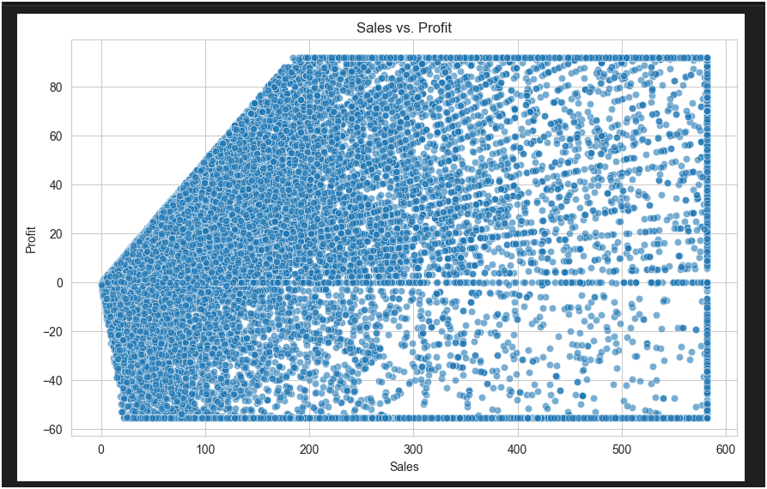

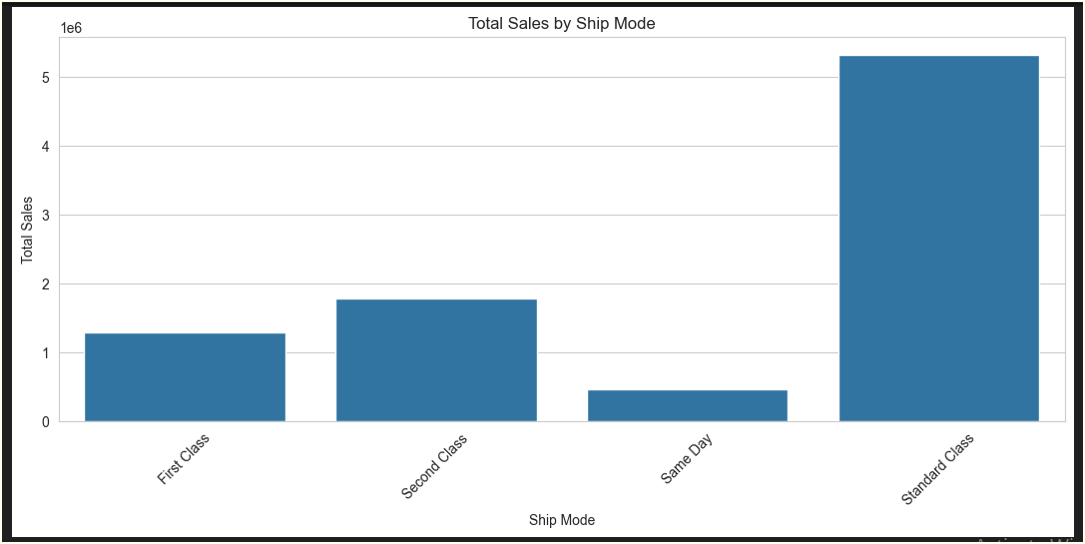

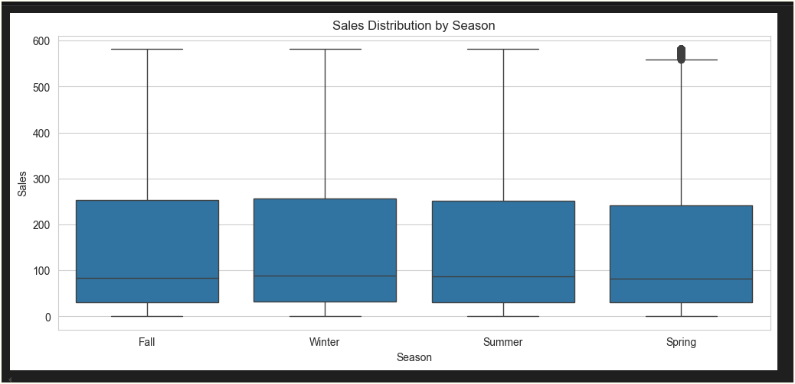

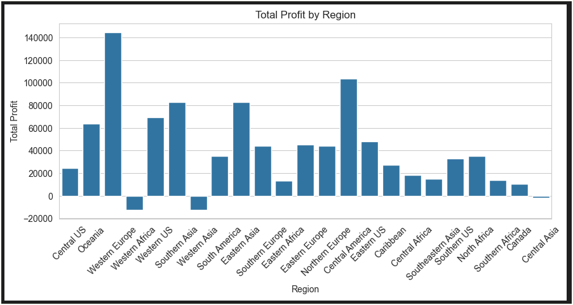

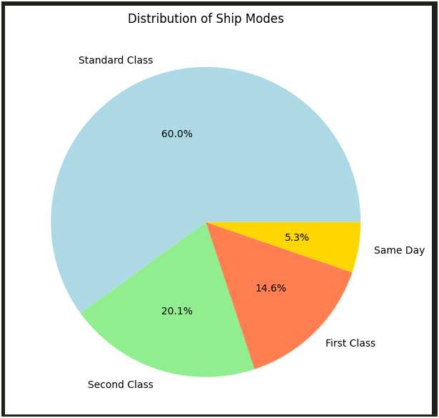

**Recommendations:**

1. **Optimize Discount Strategies**
   * Implement tiered discounting to ensure profitability, avoiding excessive discounts that lead to losses.
   * Analyze which discount levels yield the highest ROI and adjust promotions accordingly.
2. **Reassess Shipping Costs**
   * Investigate whether **high shipping costs correlate with lower sales**.
   * Offer free or discounted shipping on high-value purchases to incentivize more orders.
3. **Enhance Promotions for High-Profit Items**
   * Promotions should focus on **high-margin products** rather than indiscriminately discounting items.
4. **Leverage Seasonal Sales Trends**
   * Allocate marketing budgets for peak seasons where sales naturally increase (e.g., Q4 holiday shopping).
5. **Further Exploration of Customer Segments**
   * Identify high-value customer segments and target them with personalized promotions.
   * Consider customer purchase history to predict future buying behavior and tailor marketing strategies.